Tyler Burleson

Add your submission guidelines to this page.  
Answer each question below.

** Indicates you must have a screenshot, otherwise the screenshot is optional and you may type your answer.

For this assignment, use the BowlingLeague database.

1. List all steps required to connect to the Linux server from your computer.

Open MobaXterm

Start a session in the top left corner

Select SSH

Enter in the host name-cscilinux.northeaststate.edu

Specify a specific username

Enter your user name

Hit ok

Enter your Linux Password

1. ** Show the subdirectories that are in your Linux root folder.



1. How do you create a new folder in Linux?



1. How do you remove a folder in Linux?



1. How do you know you have successfully logged on to the Linux server?

When you see the (username)@cscilinux:~$ prompt

1. ** What is the command to log on to MySQL?



1. ** What is the statement to “see” all the databases available for you to use in MySQL?

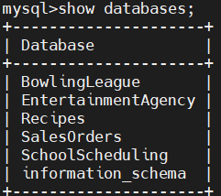

1. ** What is the statement to list the tables in a database?

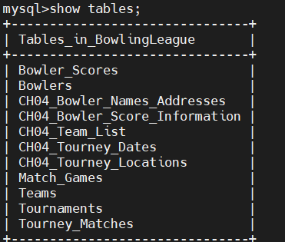

1. ** How do you identify what the fields are in the Teams table?

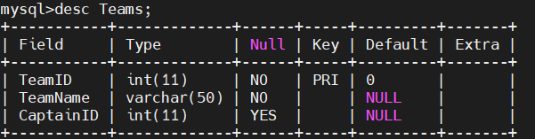

1. ** What table has the TourneyDate field?

Tournaments

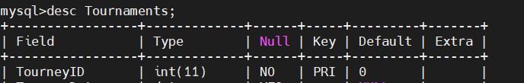

* 1. What is the field type for TourneyDate?

date

1. What is a primary key?

A unique constraint that identifies each record in a table

1. ** What is the primary key(s) for the Match_Games table?

MatchID & GameNumber

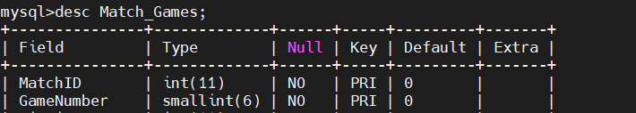

* 1. Can the primary key(s) for the Match_Games table have Null data?

No

1. What is wrong with this command?



It is missing FROM before the table name(Bowlers)

1. ** Display the last name, first name and BowlerID for the bowlers. The columns should be headed as “Last Name”, “First Name” and “Bowler ID”.

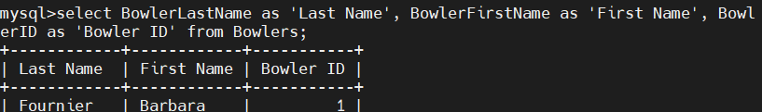

1. What is wrong with this command?



SHOW needs to be replaced with SELECT

1. **Show the Bowler’s First Name and Last Name for all the Bowlers that have a middle initial of L.

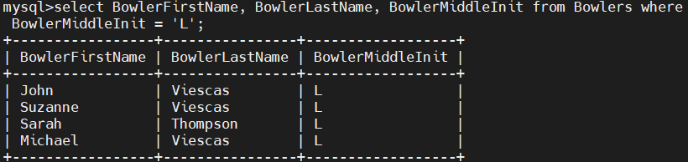

1. What is the purpose of the WHERE statement?

To help filter what you want selected

1. ** List all the Bowler’s First Names and Last Names who live in Bothell.

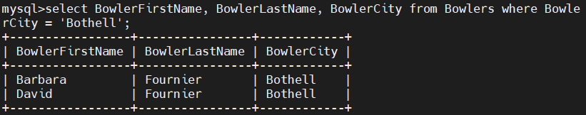

1. Where do you type: **vim filename.sql** (to access the vim editor)?

In the directory that has the file Ex: sql_scripts

1. Where do you type: **\. filename.sql** run your file?

In the mysql prompt

1. What are all the steps to exit from MySQL, Linux and MobaXterm?

(starting inside MySQL)

Type: exit

Once inside the linux directory type: exit

Hit the Esc Key

Hit the red Exit button on the top right